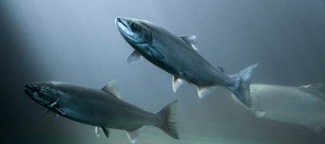
Climate Resilience – A New Way of Thinking about how Capitol-Funded Habitat Projects Impact Salmon
Chehalis Basin Collaborative for Salmon Habitat (Lead Entity)
For: 2025 SRFB Grant Round
What is Climate Resilient Habitat?


Stream systems that stay intact in the face of impact from climate change (changes to heat and water over time).
How can we make a difference at a project level?
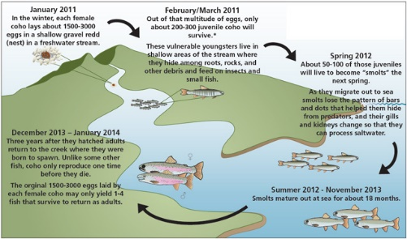
Some physical actions may improve the ability of a stream system to withstand the impacts from climate change. This in turn impacts salmon during the life stages that use that habitat. The changes we make through physical changes to the land may be small, but if we start now, we may be able to build more climate-resilient habitat throughout a species’ freshwater lifecycle.
How will climate resilience be evaluated at a project level?
The Chehalis Basin Collaborative for Salmon Habitat is going to evaluate all SRFB proposals submitted in 2025 for how they address climate resilience. The process for sponsors and the local (Lead Entity) review team is explained below.

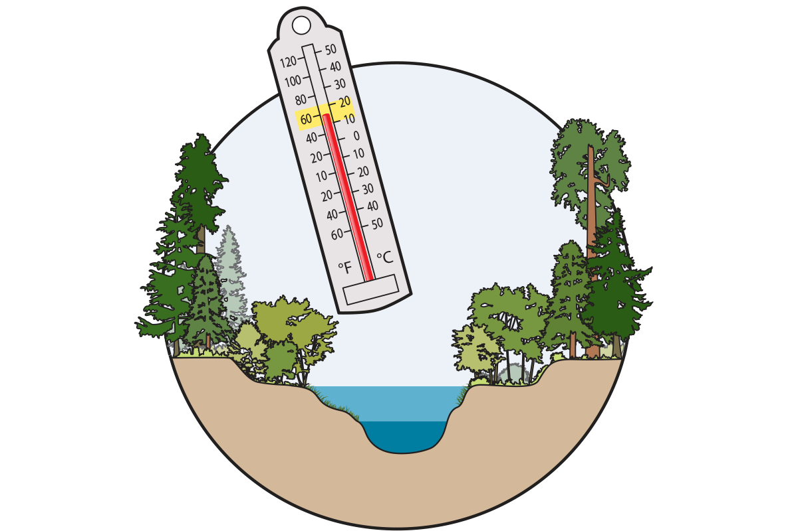
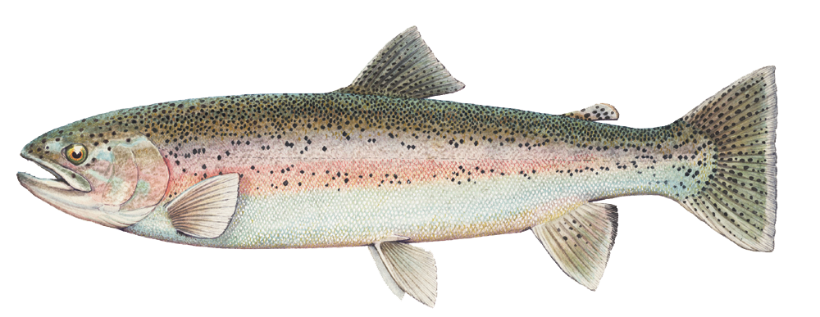

The Review Team will look to make sure that the project sponsor understands their project action in the context of a changing climate. Projects will receive points for how well they explain the connection between climate stressor, life stages affected, and how the project would mitigate for that impact. Projects will not be scored on how large of an impact they have on climate resilience in this grant round.
I) Resources Sponsors Must Look at and Reference in their Application:
Climate Stressor
Life Stage Impacted
How the project mitigates for impact
!
- Webmap: https://coastsalmon.maps.arcgis.com/apps/webappviewer/index.html?id=dedec4f07b2a4b68a496f1cc892ff9e7
- Table of Life-Stages affected by climate stressors: Table in Appendix B, of: https://coastsalmonpartnership.egnyte.com/dl/MnHu1VmItV
- Salmon Restoration and Resilience in a Changing Climate: A Guide to “Future Proofing” Salmon Habitat in the Washington Coast (2023)/ aka “Reference Guide” https://coastsalmonpartnership.egnyte.com/dl/MnHu1VmItV
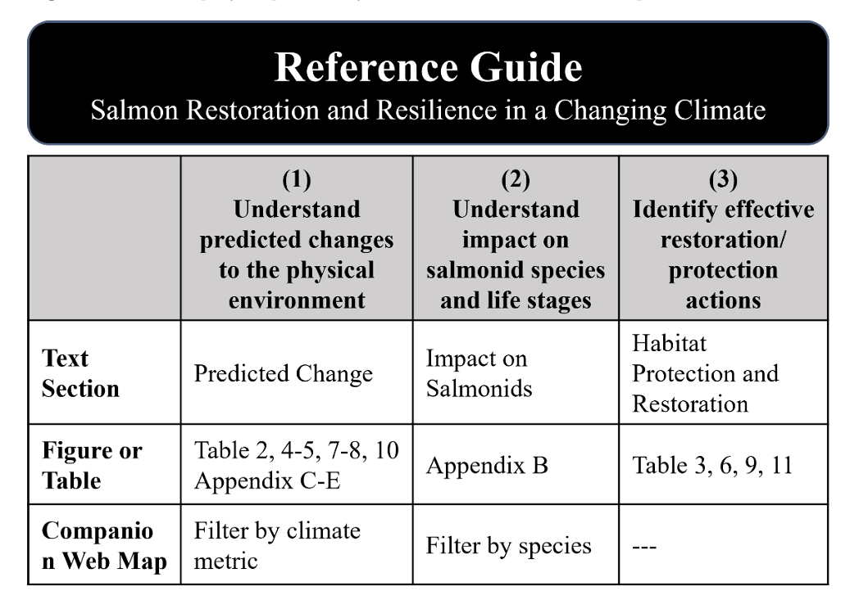

II) Steps for Sponsors in their Application:
1) Use the webmap first. The sponsors should navigate to and then click on the reach they plan on restoring or protecting and look for the projected changes (summer flow, winter flow, and/or summer temperature). They may find big stressors at their site, or small stressors.
***Write down stressors present and whether they are high, medium, or low.
Stressor Present? ____ Intensity? ____________________
Stressor Present? ___ _ Intensity? ____ __
Stressor Present? _____ _________________ Intensity? ___
-E.g., A 40% mean change may be considered a high stressor, and < 10% max change may be considered a low stressor
2) Next look at the Salmon Life Stage table to find life stage that might be present in a stream when each stressor is present. Which life stages are most affected by the stressors the tool shows as being present and a major force?
***Write down species and life stage affected.
Spawning: Species affected ________________________________________________
Adult Migration & Holding: Species_________________________________
Rearing: Species affected ___________________________________________________
Incubation: Species affected ________________________________________________
-E.g., Rearing juvenile Coho would be affected by higher summer stream temperatures in a tributary.
3) The Sponsor should think through how their project interacts with the expected impacts of climate change and salmon life stages. Then they should think through if their action mitigates that impact.
-How you might think about this question:
A) If your project benefits spawning adults, but the climate impacts are only to summer temperatures and low flows, then there isn’t overlap between your project action and the climate stressor. Write down the impact of your project on climate resilience as “minimal.”
B) If your project is a culvert that opens up access to adult spawning habitat, and you will make it wide enough to accommodate high winter flows where they are known to be a major stressor, write down that this is a significant impact.
(see the Reference Guide for recommended actions to mitigate for each stressor in Tables 3, 6, 9, 11: https://coastsalmonpartnership.egnyte.com/dl/MnHu1VmItV )
Project’s Impact: _______________________________________________________
4) Document your responses to these questions in two places in your application:
First, fill out the information in the Lead Entity’s “Supplemental Questions” form and include it as an attachment in PRISM. You will be prompted to answer each question in the Supplemental Questions document.
In PRISM, put this information in Question 10. The PRISM question is worded slightly differently, but you should be able to cut and paste the same wording in your response.
III) Obligations of the Local Review Team
-Read the answers to questions about climate resilience in the Supplemental Questions attachment which will be uploaded into PRISM.
-This information will also be summarized in the “SRFB Project Details at a Glance”, compiled by the Lead Entity Coordinator.
-There will be one question worth 4 points (4.7% of total project score) in the Overall Benefit Category. The question is:
Does the proposal address climate resilience?
8a) Does the proposal describe critical climate stressors that will impact the project site, with a general indication of how much influence they will have (H, M, L)?
8b) Does the proposal identify the species and life stages that will be most impacted by the climate stressors? (1 pt)
8c) Does the project adapt or mitigate climate stressors to increase resilience of the affected species/life stage and habitat-forming processes? (2 pts)
Other places climate resilience might be evaluated in the evaluation criteria:
-Question 1) Critical Need: The sponsor may describe how Climate Change is a threat to the species and how the project will reduce that threat. They may also describe “imminent threat” in this response. We will mostly consider how the sponsor explains the critical need for the project at this point in time and won’t expect Climate Change to be part of that.
-Question 9) Approach – Science Based. The sponsor may describe their project as being guided by climate resilience planning science. They will also likely discuss how science informed their site selection or project design, for example, following Stream Sim guidance. We will consider various interpretations here and won’t expect Climate Change to be part of their answer.
-Question 5) High Priority Areas and Actions. The sponsor may describe the action and area as being high priority for climate resilience, such as providing linear access to cold water refugia in a stream likely to maintain cool water in the 2080s. This type of justification may be considered in addition to whether the project takes a Tier 1 action according to the Lead Entity Strategy.

Other Resources:
- Watershed Report Cards: https://coast-salmon-partnership.shinyapps.io/CRI_app/
(Go to the Region Overview tab and click on the HUC for which you would like the report card.)
- Adams, G., Zimmerman, M, (2024) Climate Resilience Index for the Washington Coast Region: User Guide to Model, Data Sets and Interactive Tool. Coast Salmon Partnership. https://coastsalmonpartnership.egnyte.com/dl/zdDxxvQRGO
- Adams, G. and Zimmerman, M. (2023) Salmon Restoration and Resilience in a Changing Climate: A guide to “Future Proofing” Salmon Habitat in the Washington Coast Region. Coast Salmon Partnership “: https://coastsalmonpartnership.egnyte.com/dl/MnHu1VmItV

